Project Name: Global Client Onboarding and Engagement (GLOBE)

SHORT PARAGRAPH ON PROPOSED PROJECT:

Janus current independent onboarding processes involves a large number of internal teams and a combination of systems and spreadsheets. As Janus continues to evolve, the presence of bifurcated processes for onboarding creates inefficiencies and operational risks that could significantly impact client experience and introduce reputational risk. The need of Global Client Onboarding and Engagement (GLOBE) is identified to address current onboarding process inefficiencies and operational risks.

Global Client Onboarding and Engagement (GLOBE) program is a single, global system that facilitates the process to ensure that:

- (1) Appropriate approvals are clearly defined for business lines and regions;
- (2) Centralization of available account details in order to streamline the operational and onboarding setup process involving both internal teams across the organisation, as well as third parties such as BNP
- (3) Visibility and tracking of onboarding status is provided
- (4) Consistently excellent client onboarding experience is delivered regardless of region.

Global Client onboarding program is an effort under the strategic digital transformation effort for the Janus Institutional Business that manages entire asset management portfolios in collaboration with Risk Process Management (RPM) group of Janus.

Persistent’s role in this project is to collaborate with business and technical teams to understand business and integration needs, recommend technology solutions to business requirements, build solutions and product workflow in Appian in a sustainable and effective means and train the technology partners on the product workflow through working sessions.

Janus plans to develop this product in different releases. Below is a high-level plan which will be re-evaluated at the start of every quarter. Based on any changes to project priority, the order in which the projects are taken up might change. The scope and duration of each project might change with additional/removal of requirements. All these changes will be based on consultation with the business and business priority.

Following will be the key features that are planned so far for coming releases using Appian BPM suite tool:

- GLOBE Release-1: Agreement Review process.
- GLOBE Release-2: Onboarding set up process.
- GLOBE Release-3: Legal and Compliance process and.
- GLOBE Release-4: Counter party and corporate accounting.
- GLOBE Release-5: Enterprise risk and Research flow.

Project Timelines
- GLOBE Release-1 – Q1 Q2_2019 : Completed
- GLOBE Release-2 – Q3, Q4_2019,Q1_2020 : In Progress
- GLOBE Release-3 – Q1, Q2, Q3, Q4_2020 :Planned
- GLOBE Release-4 – Q1, Q2,Q3_2021 :Planned
- GLOBE Release-5 – Q3, Q4 2021 :Planned
Below chart depicts the release plan for the above mentioned GLOBE milestones for next 3 years

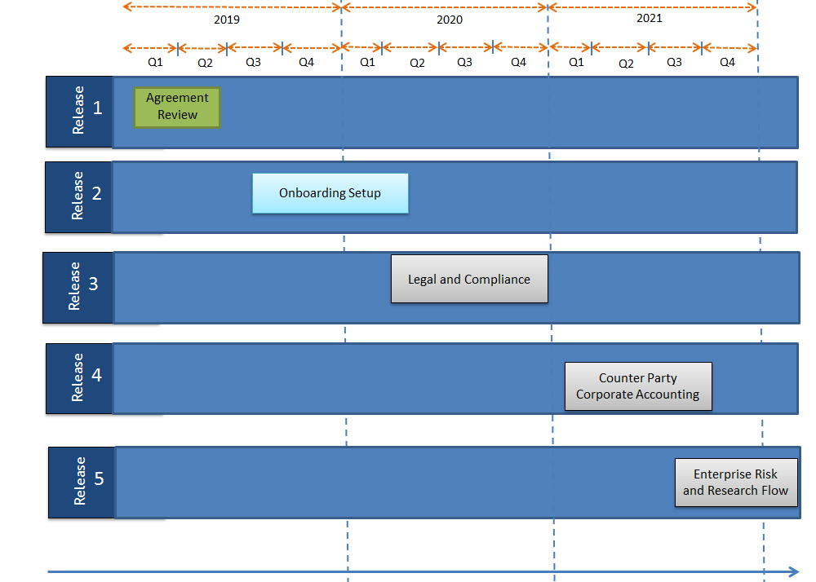

Key Features built and released so far:

- Custom plugin development using Java to integrate with their legacy ESB systems to retrieve market data
- Migration from on premise environment to Cloud based environment
- Single Sign on LDAP authorization at enterprise level.
- Sales force integration from APPIAN through the APPIAN out of the box connectors.
- SharePoint integration from Appian through the APPIAN out of the box connectors.
- Event/Notification handling framework to trigger email and system alerts
- Add-in deployment to complete the APPIAN tasks within Microsoft Outlook.
- Predictive analytical and Management Information reports using APPIAN reporting capability

Job Duties Description

Rajasekhar Hasti will perform following specialized job duties

Specialized Duty
Appian BPM Design and Implementation for Global Client Onboarding and Engagement (GLOBE) project

Detailed Description of this Job Duty:

- Define a scalable and flexible Technical Architecture for the Global Client onboarding and Engagement (GLOBE) project which not only automates but also improves the efficiency of the business functions for a single digitized centralized application.
- Design conceptual workflows and interactive User interfaces based on the requirements gathered and implement quick Proof of Concepts for proposed technical solutions.
- Design and build intuitive, reusable Appian interfaces using SAIL forms, BPMN workflows, Record dashboards, Tempo reports, Custom Data Types adhering to Appian best practices and recommendations
- Design and highlight the connectivity capabilities of Appian by building Integration which connects the existing Janus enterprise systems with Appian for business intelligence to transform data into meaningful insights to take decisions on the approvals in the onboarding process
- Review Business Process Model Processes and SAIL Forms, recommend updates to optimize them to increase efficiency and performance, reduce load times and KDB memory prints, minimize Integration Services wait times and error handling (retry or fallback) mechanisms in case of timeouts or safeToRetry (transient) exceptions
- Determines implementation best practices for GLOBE applications/modules which includes but not limited to backward compatibility, avoid race conditions, multi instance creation for a single workflow, safe termination of long running relation action instances using exception timers etc.
- Create Microsoft Structured Query Language (MS SQL) relational database objects, stored procedures, Views that define and persist business information and build Appian WebAPI’s, Connected System Objects and Integration rules to transfer information across Enterprise systems.
- Work with Janus’s Appian Architecture team on complex technical requirements and deliver reusable assets to integrate with existing and external systems
Relevant Courses:

- Object Oriented Programming (OOPS)/Java Programming.
- Design and Analysis of Algorithms
- Computer Organisation
- Computer Networks
- Database Management System ,Data processing, Data structures and File organisation
- Software Engineering
- Operating Systems
- Theory of Computation(Automata Theory)
- Managerial Information System (MIS)
- Management Science (MS)

Connect Courses to Duty:

Object Oriented Programming (OOPS)/Java Programming:
- GLOBE application is being implemented using Appian BPM Suite tool where this tool is developed using Java and OOPS concepts. So knowledge gained using OOPS subject helps Mr. Hasti in understanding the platform to provide solutions, design and architect end to end complex,robust,scalabe and production ready application
- This subject also enabled Mr. Hasti in completing the APPIAN Lead Designer, Appian Designer certifications which are benchmarks for people with APPIAN expertise
Design and Analysis of Algorithms:
- This subject helps Mr. Hasti to understand basic strategies of algorithm design: top-down design, divide and conquer. Average and worst-case criteria. Choice of appropriate data structures: arrays, lists, stacks, queues, trees, heaps, priority queues, graphs, hash tables. Applications of sorting and searching, discrete optimization algorithms, dynamic programming.
- This subject helps Mr. Hasti to build schedulers in Appian to trigger several processes to automate several actions that cannot be completed in real time but does not require user intervention to reduce human interaction.
Computer Organisation:
- This subject helps Mr. Hasti to understand different computer configurations in development, QA, UAT and Production environments. This also allows me to understand configuration needs that are required to run tools and software like Appian BPM, MS SQL Studio, Visio, Jira required for development and daily work.
Computer Networks:
- This subject knowledge allows Mr. Hasti to understand and work on daily used components like: Email exchange servers, email clients like outlook, lotus notes, Online chat, call and video phone tools like Lync and Skype, Online conferencing tools like WebEx to join meetings from remote location, Virtual Private Network tools to connect to client network from remote location, Sharing documents between different environments and other developers, allowing to access, develop applications on Appian hosted on client’s location
Database Management System ,Data processing and File organisation:
- This subject helps Mr. Hasti to understand how Appian stores organize internal and business data in the database system using different schemas/databases, to create analytical reports for the end user of GLOBE application so that users are in a position to take decision whether they can onboard a client for their investment portfolio management.
- By using this subject knowledge Mr. Hasti will be able to access different databases/schemas in different environments using Microsoft SQL Server and Management Studio. This also allows me to understand how to write SQL Scripts and Stored Procedures that are to be used in GLOBE application for different environments to access, store and process onboarding data.
Software Engineering:
- This subject helps Mr. Hasti to understand and use of different sub-disciplines of software engineering that are necessary for the development life cycle of GLOBE application. Some of them are: Gathering requirements from End users, preparing user stories Requirements Analysis, Design, Implementation, Unit Testing, Maintenance and Configuration Management.
Operating Systems:
- GLOBE application is being built using Appian BPM suite which is compatible to run in all of the Operating systems. So this subject helps Mr. Hasti in understanding the requirements and build a scalable application that runs in all operating systems
Theory of Computation(Automata theory):
- This subject helps Mr. Hasti in understanding basic terminologies which are frequently used in theory of computation – Symbols, Logical operators, Strings, Appian SAIL programming .Appian SAIL UI framework which is a patented framework that takes declarative UI definitions to generate dynamic, interactive, and multi-platform user experiences to build amazing interfaces quickly, and deploy them everywhere.
Managerial Information System(MIS):
- This subject helps me in understanding the data in existing legacy applications by integrating with Appian. So that data retrieved are used in creating reports so that end users can make decision to onboard a specific client in the GLOBE application as well business line managers can take managerial decisions and provide approvals for onboarding the client
Management Science:
- Management science is a core function of every organization and explains how the processes of Management can be best utilized to help organization to succeed. So this subject helps Mr. Hasti in understanding the complex GLOBE application and provides the thought process of architecting the application by taking managerial views and managerial processes and also helped to adhere to the investment industry best practices to solution a robust, scalable application.

Specialized Duty
Communicate with Software Architects, Business Analysts ,Subject Matter Experts(SMEs) and Product Owner to understand and implement requirements and team interaction :

Detailed Description of this Job Duty:

- Work closely with the Business Subject Matter Experts to understand and analyze requirements, finalize business scenarios for Appian process modelling.
- Huddle with the technology teams to define the Relational data model for the Business processes and review the Business Processes built by the technical teams to improve efficiency.
- Participate in Scrum Agile ceremonies (2 weeks sprint) and help the Product Owner and Business Analysts in writing effective user stories, improve the quality of the backlog and estimate user stories using Planning Poker or The Bucket System estimation techniques.
- Acts as the thought partner for designing by applying Appian features in a way that best represents the business domain.
- Works with Subject Matter Experts (SMEs) to optimize existing Business Processes to Eliminate redundancies, Streamlining and/or Automating workflows and Improving Communication
- Work closely with Janus technology teams and business line managers to do research on using Appian to integrate with technologies like Robotic Process automation (RPA), Artificial Intelligence (AI) and Machine Learning (ML) to automate the routine tasks on onboarding process to get seamless customer experience and efficiency, saving costs , drive more value to customer, get insights and actions to improve onboarding experience
- Provide inputs to junior developers about the coding practices and application knowledge.
- Train new team members with the application knowledge and provide them needed support.
- Review code changes made by junior team members and make sure they are coded as per standards.
Relevant Courses:

- Software Engineering
- Managerial Information System (MIS)
- Management Science (MS)
- Computer Graphics

Connect Courses to Duty:

Software Engineering:
- This subject helps Mr. Hasti to understand and use of different sub-disciplines of software engineering that are necessary for the development life cycle of GLOBE application. Some of them are: Gathering requirements from End users, preparing user stories Requirements Analysis, Design, Implementation, Unit Testing, Maintenance and Configuration Management.
Managerial Information System(MIS):
- This subject helps me in understanding the data in existing legacy applications by integrating with Appian. So that data retrieved are used in creating reports so that end users can make decision to onboard a specific client in the GLOBE application as well business line managers can take managerial decisions and provide approvals for onboarding the client
Management Science:
- Management science is a core function of every organization and explains how the processes of Management can be best utilized to help organization to succeed. So this subject helps Mr. Hasti in understanding the complex GLOBE application and provides the thought process of architecting the application by taking managerial views and managerial processes and also helped to adhere to the investment industry best practices to solution a robust, scalable application.
Computer Graphics:
- This subjects helps Mr. Hasti in creating complex workflow diagrams using Tools such as MS Visio based on the business requirements gathered from the end user, product management, business analysts and helps him in transferring the workflow to Appian process work flow so that a complex process can be easily transformed to efficient process and end user of Global client onboarding application can easily perform all the approval process in fast and efficient manner.

Specialized Duty
Create Application Distribution Containers, Configuration Scripts, documentation and Release planning activities:

Detailed Description of this Job Duty:

- Create/Review Appian application distribution containers (patches) and Environment specific configuration scripts for software distribution to Sandbox, QA, UAT and Production Environments.
- Create/Review Operating procedures, Pre & Post deployment steps to help Application and Release management teams to deploy Appian application distribution containers and Custom Appian plugins in higher environments
- Work with Scrum Master, QA and Technical teams to plan release schedule (Sandbox, QA, UAT, Prod and Normalization environments) for each delivery cycle, create/review intake forms for planned deliveries and work with Release Management team to execute the scheduled deployment plan.
Relevant Courses:

- Software Engineering
- Network Theory
- Project Work in final Semester

Connect Courses to Duty:

Software Engineering:
- This subject helps Mr. Hasti to understand and use of different sub-disciplines of software engineering that are necessary for creating application distribution containers (patches),configuration scripts to deploy to QA,UAT and production environments of GLOBE application
Network Theory:
- This subject helps Mr. Hasti in understanding the multiple server configuration mappings out of which servers will run the various architectural components of the Appian software
- This subject helps Mr. Hasti understand the concepts of High availability ,load balancing ,Security configurations, single sign on so that I can effectively configure and deploy the Global client onboarding application in all environments including Production
Project Work in final Semester :
- This course provided Mr. Hasti knowledge on agile methodology where each work was done in phases and iterative mode. Final demo was performed after completion.

Specialized Duty
Application Support:

Detailed Description of this Job Duty:

- Analyze business critical bugs reported in production with the help of System analysis tools like Splunk, Appian Process Instance Monitor and provide a quick turnaround so Business function is unimpeached.
- Create and review Runbooks for production support teams to resolve frequently observed technical glitches in the Appian platform.
- Work with Appian's Center of Excellence group on potential performance and scalability issues in the Appian platform and come up with a quick turn around on such critical items.
- Perform Risk evaluation of production incidents and work with Product owner to prioritize incidents
Relevant Courses:
- Operating systems
- Managerial Economics and Principles of Accounting(MEPA)
- Managerial Information System(MIS)

Connect Courses to Duty:

Operating systems
- This subject helps Mr. Hasti in understanding and working for GLOBE application in production which is on Linux operating system and helps him in fixing the critical business bugs reported
Managerial Economics and Principles of Accounting(MEPA)
- This course provides Mr. Hasti ability to generate and understand the complex and unique audit and accounting related reports to trouble shoot critical business bugs reported in production and provide quick solutions so that there is continuation of production systems with less or no impact to business
Managerial Information System(MIS):
- This course provides Mr. Hasti knowledge on maintaining extraordinary customer service and relationship with management and provides ability to explain complex ideas and perform complex risk evaluation of production incidents to those with limited IT and Systems Knowledge

EXPECTED TIME UTILIZATION PER JOB DUTY
The below table gives an approximate idea of the time that will be spent on each of the above major job duties:
Id | Responsibility | Approximate Time (%)
1 | BPM Design and Implementation using Global Client Onboarding and Engagement (GLOBE) program using Advanced Appian BPM suite | 50
2 | Communicate with Software Architects, Business Analysts ,Subject Matter Experts(SMEs) and Product Owner to understand and implement requirements | 25
3 | Application Containers Distribution, Configuration and Release Planning | 15
4 | Application Support | 10
 | Total | 100

The values in the above table are an approximate and actuals may vary slightly depending on specific customer needs.

